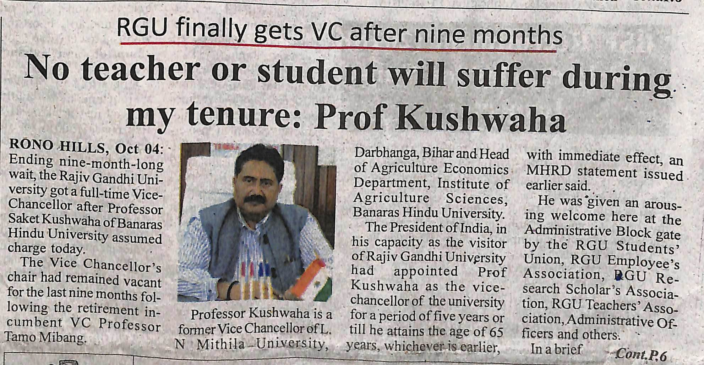

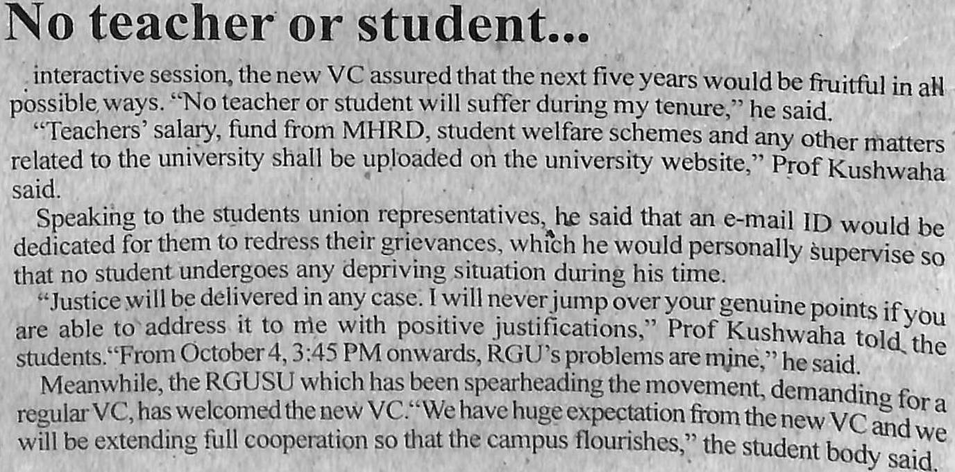

- News published in: - Arunachal Front.
- On 05th October 2018.(Friday)
- Type : Regional newspaper.
- Place : Itanagar Arunachal Pradesh

