ARUNACHAL FRONT

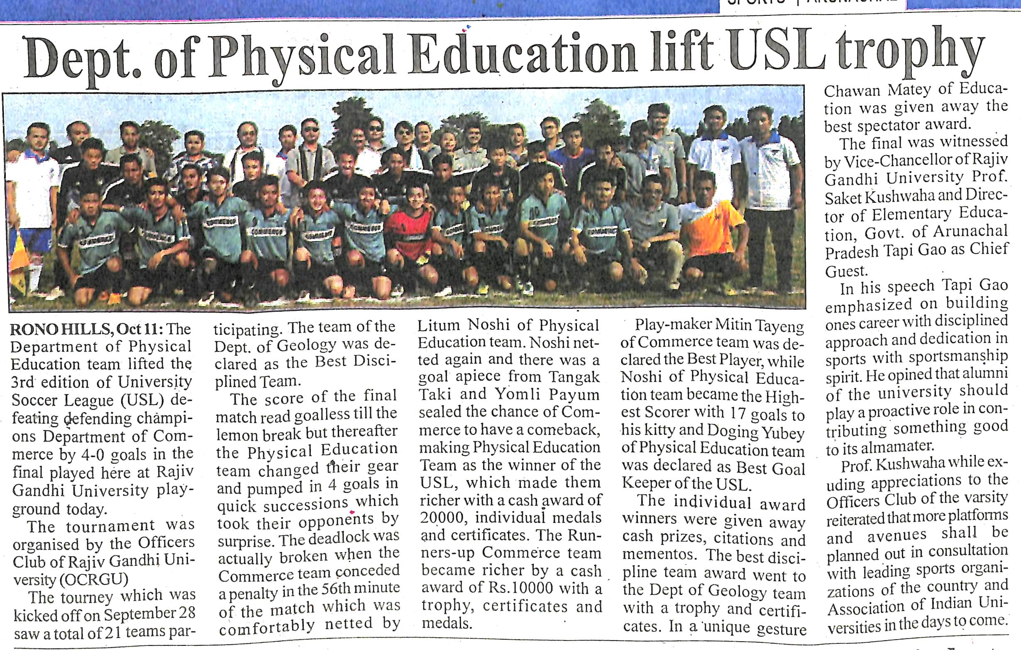

- News published in: -ARUNACHAL FRONT
- On 12th October 2018.
- Type: Regional Newspaper.
- Place : Itanagar Arunachal Pradesh

