ARUNACHAL FRONT
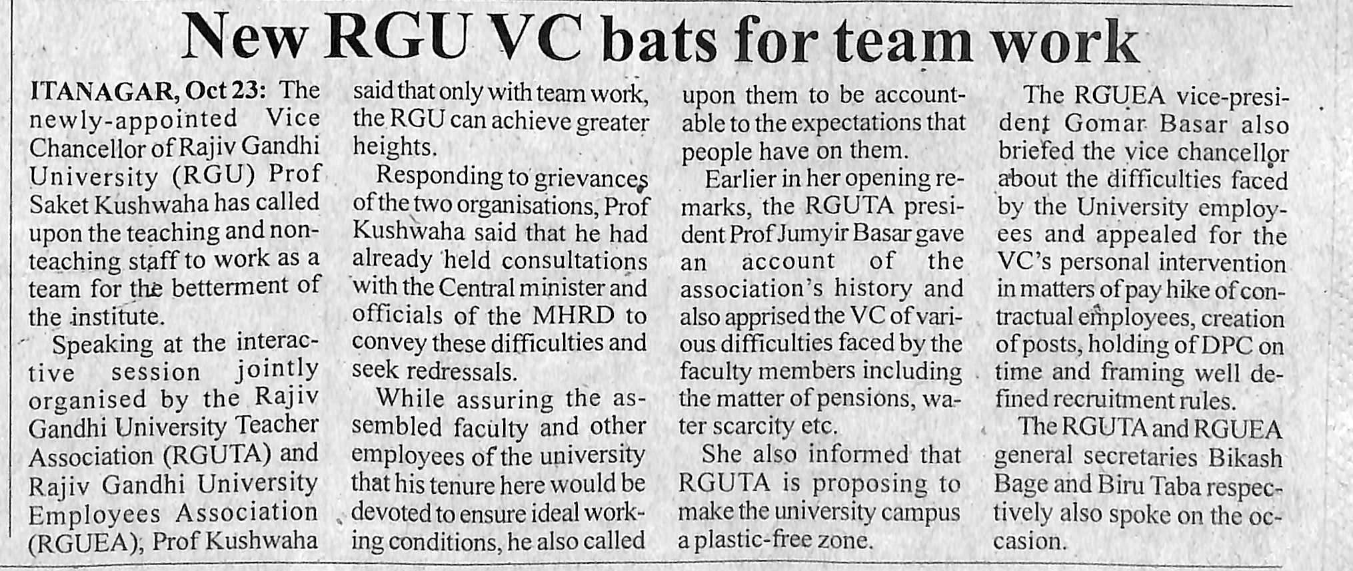
- News published in: - Arunachal Front
- On 24th October 2018.
- Type : Regional newspaper.
- Place : Itanagar Arunachal Pradesh

24th OCT 2018

