ARUNACHAL FRONT
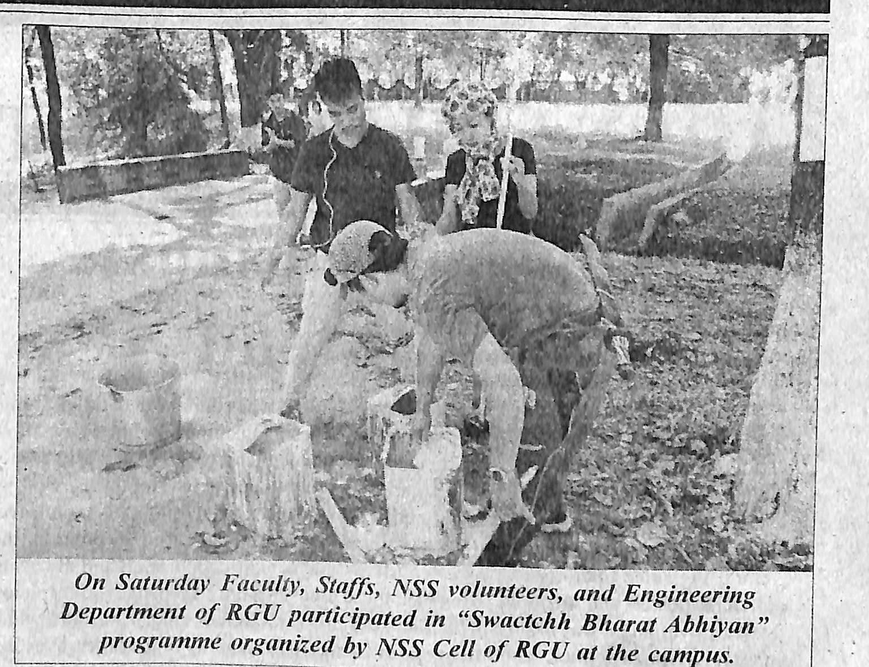

- News published in: - Arunachal Front
- On 28th October 2018.
- Type : Regional newspaper.
- Place : Itanagar Arunachal Pradesh

29th OCT 2018

