ARUNACHAL FRONT
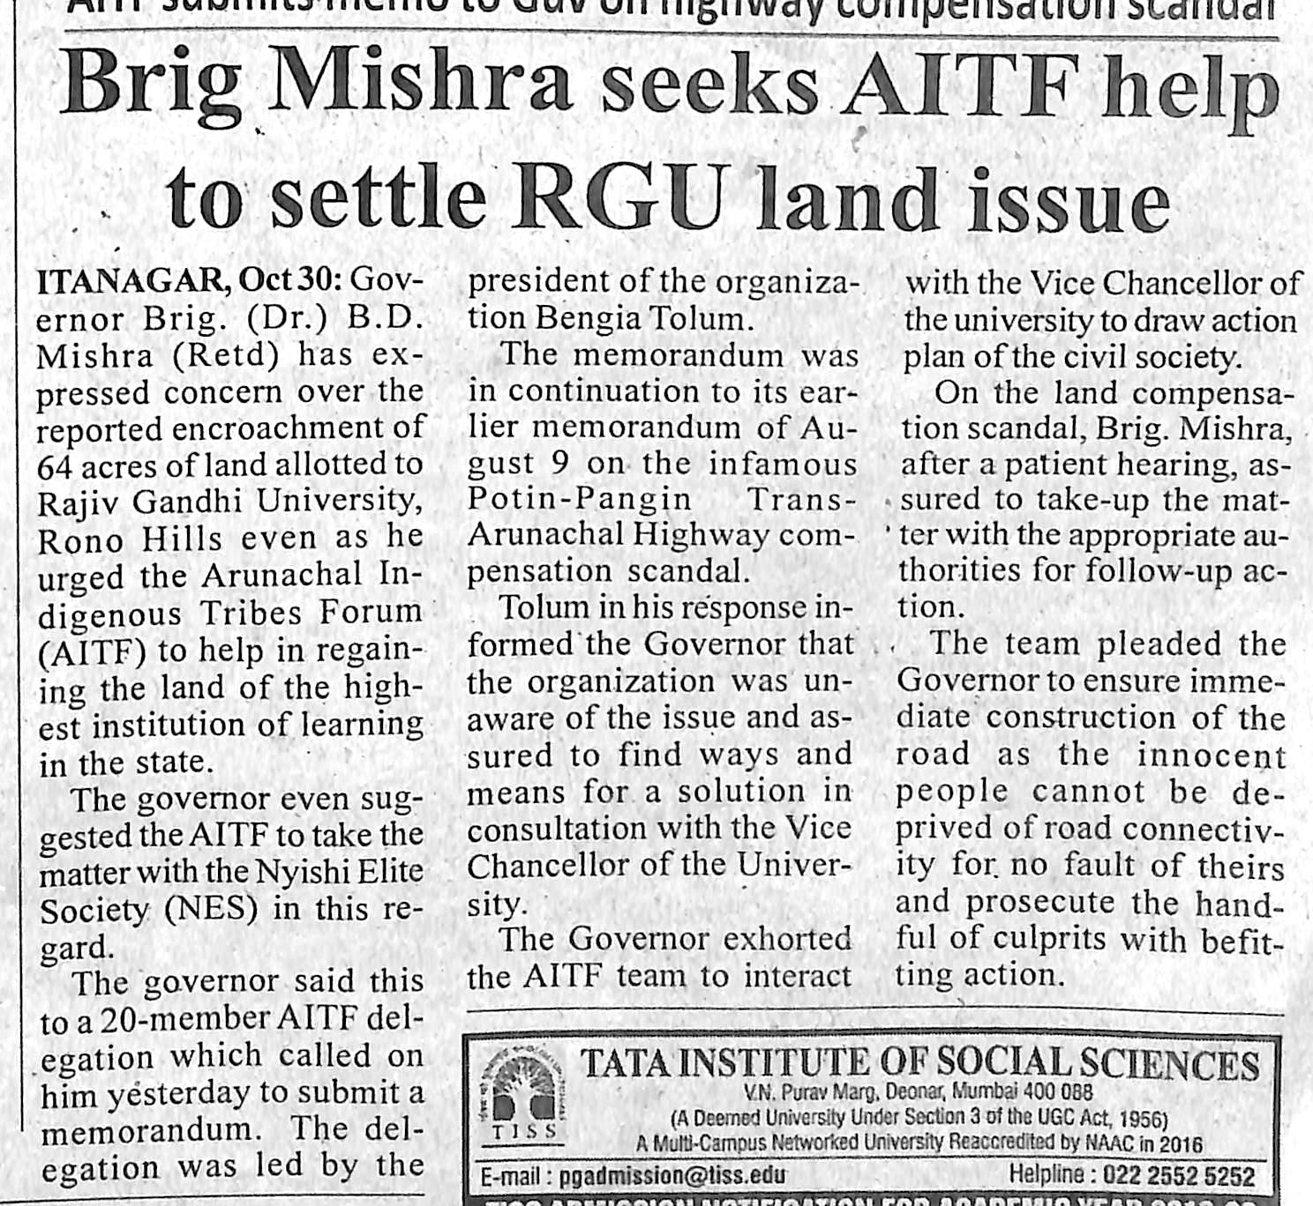
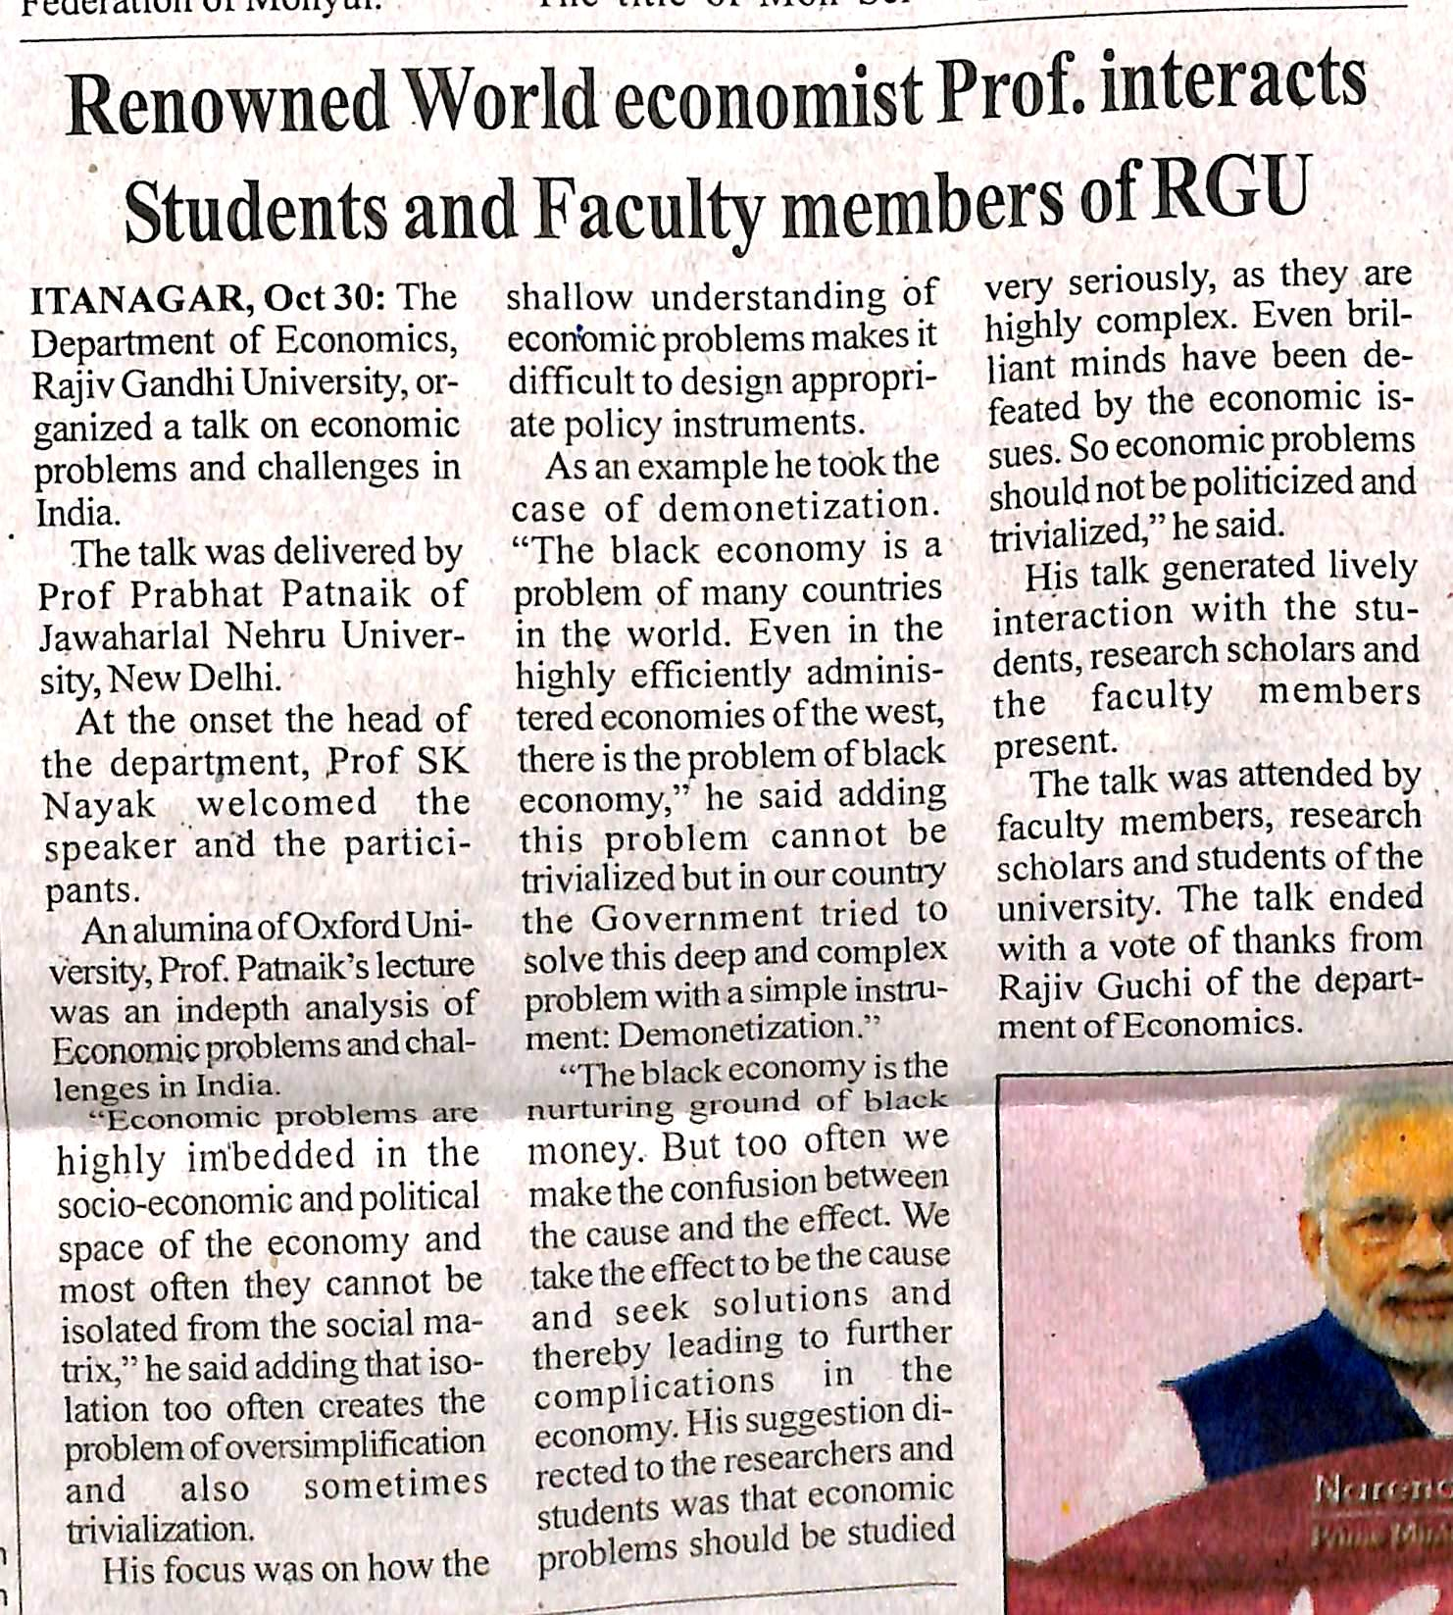

- News published in: - Arunachal Front
- On 31st October 2018.
- Type : Regional newspaper.
- Place : Itanagar Arunachal Pradesh

