ARUNACHAL FRONT
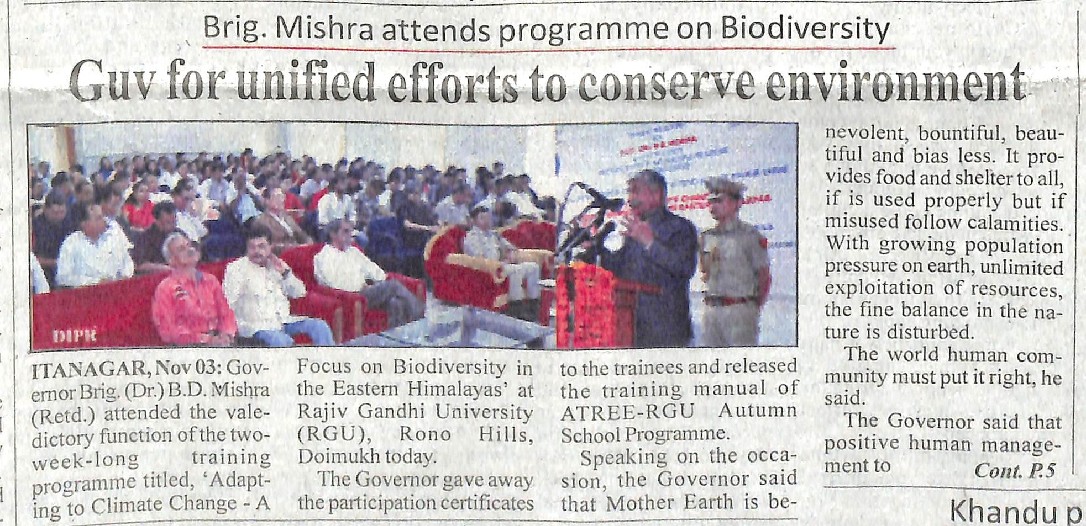
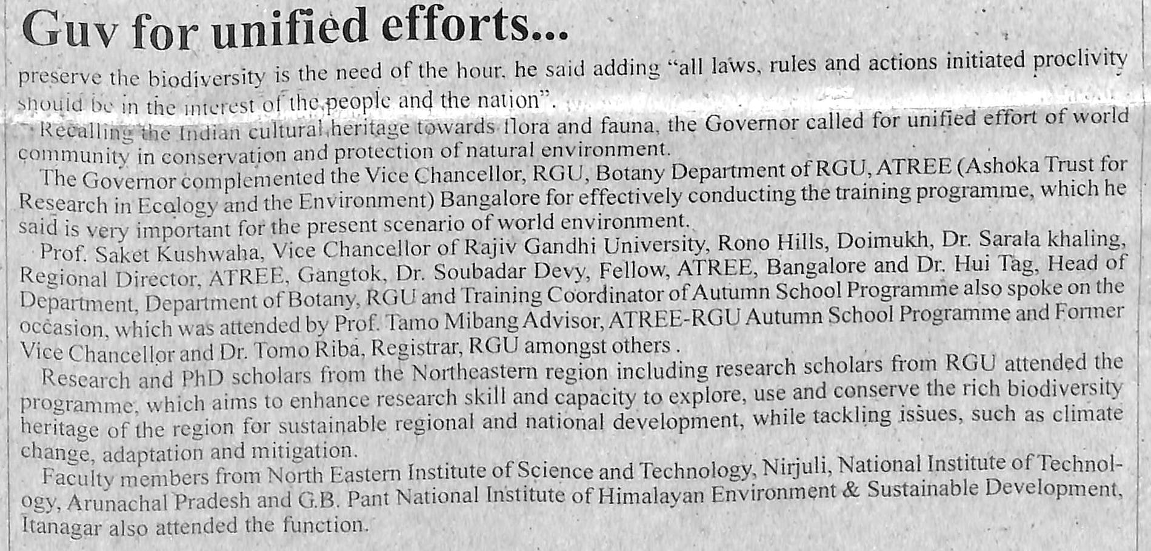
- News published in: - Arunachal Front
- On 4th November 2018.
- Type : Regional newspaper.
- Place : Itanagar Arunachal Pradesh

3rd NOV 2018

