ARUNACHAL FRONT

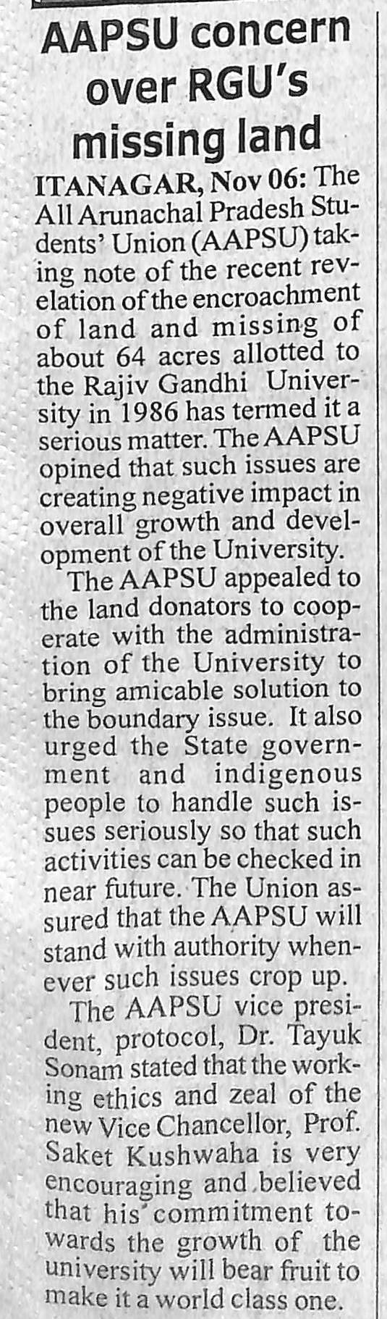

- News published in: - Arunachal Front
- On 7th November 2018.
- Type: Regional newspaper.
- Place : Itanagar Arunachal Pradesh

