ARUNACHAL FRONT
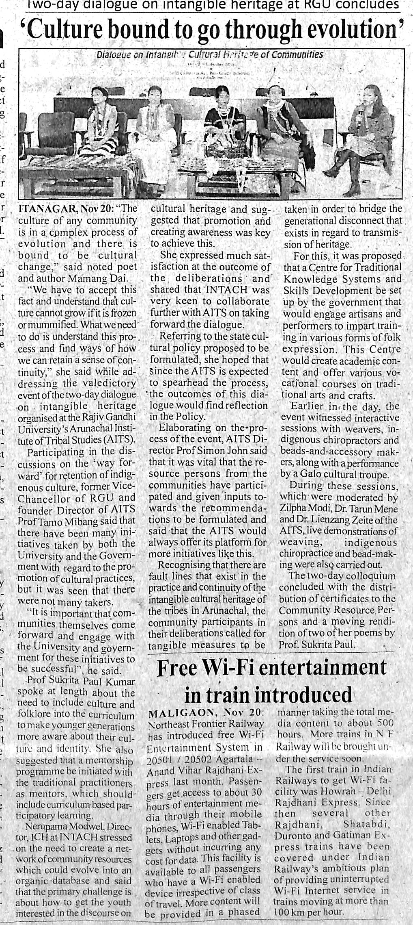
- News published in: - Arunachal Front
- On 21st November 2018.
- Type: Regional newspaper.
- Place : Itanagar Arunachal Pradesh

