ARUNACHAL FRONT
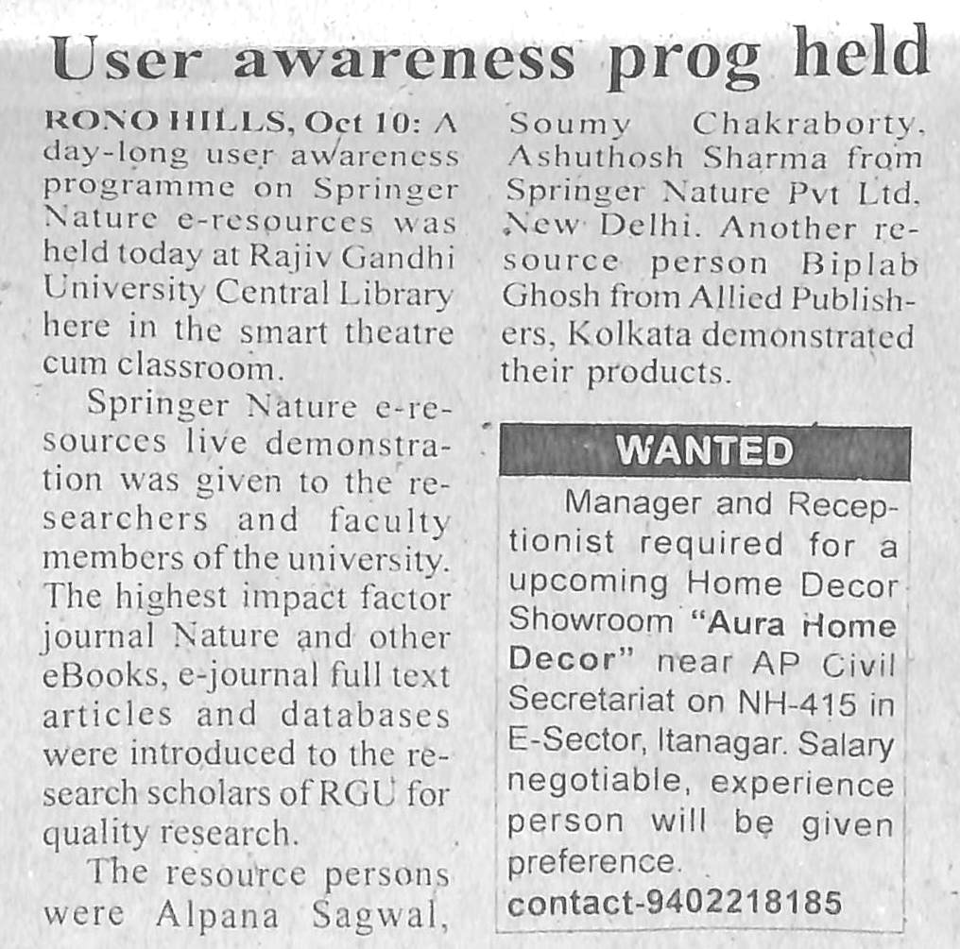

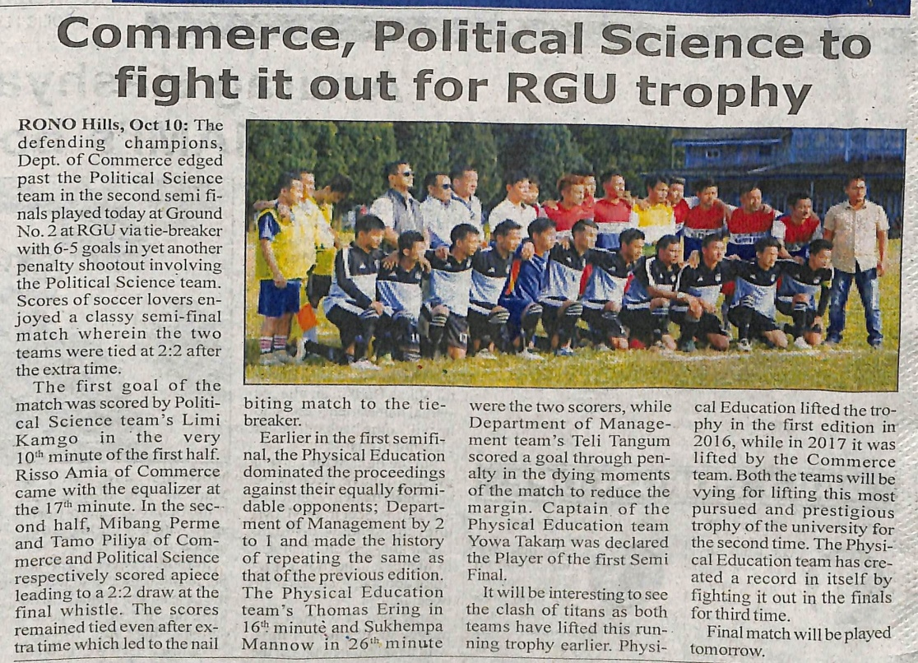

- News published in: Arunachal FRONT.
- On 10th October 2018.
- Type : Regional newspaper.
- Place : Itanagar Arunachal Pradesh

